11 HUMAN BIOLOGY

Cells & Microscope Test

Name:_____________________________ /30

**Part one – multiple choice**

*Circle the correct answer*

1. Osmosis is a special type of diffusion that deals with the movement of water molecules through a selectively permeable membrane from:

a) An area of low solute concentration to an area of high solute concentration.

b) An area of high solute concentration to an area of low solute concentration.

c) An area of diffusion to an area of low osmotic pressure.

d) An area inside a gummy bear to an area outside a gummy bear.

[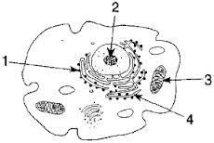](http://www.google.com.au/imgres?um=1&hl=en&biw=1920&bih=931&tbm=isch&tbnid=U89ZmWMusBTYbM:&imgrefurl=http://www.edhsgreensea.net/Biology/taters/cell_parts_quiz_mc.htm&docid=TBrWfSSVlWYqlM&imgurl=http://www.edhsgreensea.net/Biology/taters/taters_images/cell_pic.gif&w=288&h=193&ei=dlE9Ub6OCMjIkQWGxYGYDg&zoom=1&ved=1t:3588,r:78,s:0,i:319&iact=rc&dur=15069&page=3&tbnh=154&tbnw=230&start=76&ndsp=42&tx=101&ty=60)

**The following three questions refer to the diagram to the right**

2. Which of the following contains the correct name and function for **#1**

a) Ribosomes are responsible for the production of proteins

b) The endoplasmic reticulum transports substances within the cell and provides a surface for chemical reactions

c) The cytoskeleton consists of microtubules which give the cells its shape and assist with movement of materials

d) Golgi bodies are responsible for the modification of proteins

3. Which of the following contains the correct name and function for **#4**

a) The cytoskeleton connects the cell membrane transports substances within the cell and provides a surface for chemical reactions

b) The endoplasmic reticulum transports substances within the cell and provides a surface for chemical reactions

c) The cytoskeleton consists of microtubules which give the cells its shape and assist with movement of materials

d) The endoplasmic reticulum consists of microtubules which give the cells its shape and assist with movement of materials

4. Which of the organelles is involved in the release of energy through cellular respiration

a) 1

b) 2

c) 3

d) It is not numbered on this diagram

5. The following is a list of processes which may occur in a cell.

i) active transport.

ii) catabolism.

iii) respiration.

iv) osmosis.

v) anabolism.

vi) diffusion.

vii) pinocytosis.

Which processes listed above move material into, or out of, the cell?

a) iv and vi only.

b) i ,ii and v only.

c) ii, iii, v and vii only.

d) i ,iv, vi and vii only.

6. Pinocytosis is the:

a) movement of solids through a semi permeable membrane.

b) the engulfing of liquids by the cell membrane.

c) the movement of liquids out of the cell.

d) the production of pinoplasts to remove wastes from a cell.

7. Choose the **incorrect** statement.

a) Active transport moves solutes from an area of high solvent concentration to an area of low solvent concentration

b) Active transport requires energy

c) Active transport moves solutes from an area of high solute concentration to an area of low solute concentration

d) Active transport moves substances against the concentration gradient

**The following questions refer to the following microscope diagram**

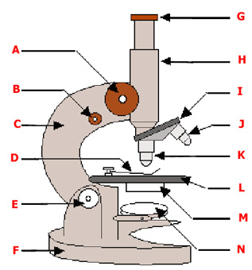8. Which of the following would need to be adjusted if the image was slightly out of focus?

a) A

b) B

c) E

d) I

9. Where would you find epithelial tissue?

a) The inside of the mouth

b) Covering the heart

c) The skin

d) All of the above

10. Which of the following is **correct** about the diagram below:

a) Diagram A has a higher magnification but a smaller field of view than Diagram B

b) A lower magnification ocular lens would have been used to view Diagram C than Diagram D

c) Diagram A has the highest field of view

d) All of the above

[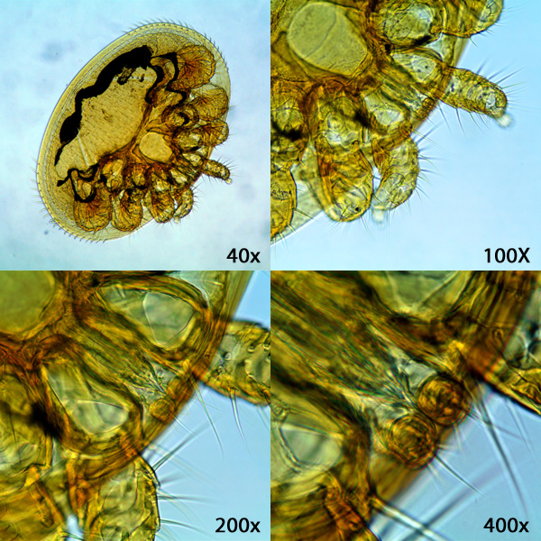](http://www.google.com.au/url?sa=i&rct=j&q=&esrc=s&source=images&cd=&cad=rja&uact=8&ved=0CAcQjRw&url=http://www.science.my/product/microscope-bundle-a/&ei=rGnQVMPrGtTe8AWvg4HQCw&bvm=bv.85076809,d.dGc&psig=AFQjCNEjQ3oK6fwDWhEb7cQzXL24oJoujQ&ust=1423031043276073)

**D**

**C**

**B**

**A**

**Part Two – Short Answer**

2. Below is a diagram of a cell membrane.

a What is the term given to the structure of membranes within the cell? (1 mark)

b What are the structures embedded in the membrane? (1 mark)

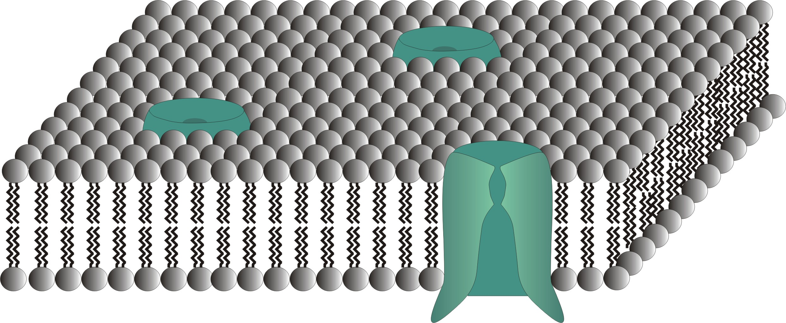

c How do these structures enable large molecules such as **glucose** to pass through the membrane? What is this process called? You may use a diagram if you wish. (3 marks)

____________________________________________________________________________________________________________________

____________________________________________________________________________________________________________________

____________________________________________________________________________________________________________________

____________________________________________________________________________________________________________________

____________________________________________________________________________________________________________________

3. Explain what the graph below is showing. (2 marks)

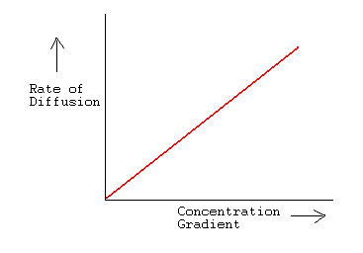

4. A microscope has the following lenses:

ocular power = 10x

low power objective = 20x

high power objective = 50x

1. What is the highest magnification you could get using this microscope? (1 mark)
2. If the diameter of the low power field of view is 2 mm, what is the diameter of the high power field of view in millimeters (mm)? Show your working (2 marks)
3. What is the high power field of view in micrometers (μm)? (1 mark)
4. If 10 cells can fit end to end in the low power field of view, how many of those cells would you see under high power? (1 mark)

5. Explain why cells are so small. (2 marks)

____________________________________________________________________________________________________________________

____________________________________________________________________________________________________________________

____________________________________________________________________________________________________________________

____________________________________________________________________________________________________________________

____________________________________________________________________________________________________________________

Part three – extended answer (**6 marks)**

There are three types of muscle tissue. Name, describe and give an example of each type.

SOLUTIONS

1. Osmosis is a special type of diffusion that deals with the movement of water molecules through a selectively permeable membrane from:

a) An area of low solute concentration to an area of high solute concentration.

b) An area of high solute concentration to an area of low solute concentration.

c) An area of diffusion to an area of low osmotic pressure.

d) An area inside a gummy bear to an area outside a gummy bear.

[](http://www.google.com.au/imgres?um=1&hl=en&biw=1920&bih=931&tbm=isch&tbnid=U89ZmWMusBTYbM:&imgrefurl=http://www.edhsgreensea.net/Biology/taters/cell_parts_quiz_mc.htm&docid=TBrWfSSVlWYqlM&imgurl=http://www.edhsgreensea.net/Biology/taters/taters_images/cell_pic.gif&w=288&h=193&ei=dlE9Ub6OCMjIkQWGxYGYDg&zoom=1&ved=1t:3588,r:78,s:0,i:319&iact=rc&dur=15069&page=3&tbnh=154&tbnw=230&start=76&ndsp=42&tx=101&ty=60)**The following three questions refer to the diagram to the right**

2. Which of the following contains the correct name and function for **#1**

a) Ribosomes are responsible for the production of proteins

b) The endoplasmic reticulum transports substances within the cell and provides a surface for chemical reactions

c) The cytoskeleton consists of microtubules which give the cells its shape and assist with movement of materials

d) Golgi bodies are responsible for the modification of proteins

3. Which of the following contains the correct name and function for **#4**

a) The cytoskeleton connects the cell membrane transports substances within the cell and provides a surface for chemical reactions

b) The endoplasmic reticulum transports substances within the cell and provides a surface for chemical reactions

c) The cytoskeleton consists of microtubules which give the cells its shape and assist with movement of materials

d) The endoplasmic reticulum consists of microtubules which give the cells its shape and assist with movement of materials

4. Which of the organelles is involved in the release of energy through cellular respiration

a) 1

b) 2

c) 3

d) It is not numbered on this diagram

5. The following is a list of processes which may occur in a cell.

i) active transport.

ii) catabolism.

iii) respiration.

iv) osmosis.

v) anabolism.

vi) diffusion.

vii) pinocytosis.

Which processes listed above move material into, or out of, the cell?

a) iv and vi only.

b) i ,ii and v only.

c) ii, iii, v and vii only.

d) i ,iv, vi and vii only.

6. Pinocytosis is the:

a) movement of solids through a semi permeable membrane.

b) the engulfing of liquids by the cell membrane.

c) the movement of liquids out of the cell.

d) the production of pinoplasts to remove wastes from a cell.

7. Choose the **incorrect** statement.

a) Active transport moves solutes from an area of high solvent concentration to an area of low solvent concentration

b) Active transport requires energy

c) Active transport moves solutes from an area of high solute concentration to an area of low solute concentration

d) Active transport moves substances against the concentration gradient

**The following questions refer to the following microscope diagram**

8. Which of the following would need to be adjusted if the image was slightly out of focus?

a) A

b) B

c) E

d) I

9. Where would you find epithelial tissue?

a) The inside of the mouth

b) Covering the heart

c) The skin

d) All of the above

10. Which of the following is **correct** about the diagram below:

a) Diagram A has a higher magnification but a smaller field of view than Diagram B

b) A lower magnification ocular lens would have been used to view Diagram C than Diagram D

c) Diagram A has the highest field of view

d) All of the above

**Part two – short answer**

1. Below is a diagram of a cell membrane.

a What is the term given to the structure of membranes within the cell? (1 mark)

Phospholipid bilayer

b What are the structures embedded in the membrane? (1 mark)

Proteins

c How do these structures enable large molecules such as **glucose** to pass through the membrane? What is this process called? You may use a diagram if you wish. (3 marks)

Facilitated Diffusion/Carrier-mediated transport 1 mark

Binds to carrier protein, which changes shape any 2, 1 mark each

Moving from area of high conc to low conc – or passive transport

Move from extra cellular to cytoplasm

3. Explain what the graph on the left is showing. (2 marks)

* As the concentration gradient increases so does the rate of diffusion - NOT accepting rate of diff affects CG as IV is on X axis
* Shows the relationship between concentration gradient and the rate of diffusion
* Diffusion occurs faster when there is a greater difference between the areas of high and low concentration

1 mark any 2

4. A microscope has the following lenses:

ocular power = 10x

low power objective = 20x

high power objective = 50x

1. What is the highest magnification you could get using this microscope? (1 mark)

500x

1. If the diameter of the low power field of view is 2 mm, what is the diameter of the high power field of view in millimeters (mm)? Show your working (2 marks)

Low = 200x

200 x 2.5 = 500 1 mark for answer 1 mark for working

2mm/2.5 = 0.8mm

1. in micrometers (μm)? 0.8 x 1000 = 800um (1 mark)
2. If 10 cells can fit end to end in the low power field of view, how many of those cells would you see under high power? (1 mark)

10/2.5 = 4

4. Explain why cells are so small. (2 marks)

An explanation that includes both:

* Surface area to volume ratio
* Diffusion
* Part three – extended answer (**6 marks)**
* There are three types of muscle tissue. Name, describe and give an example of each type.

|  |  |  |
| --- | --- | --- |
|  |  |  |
| Skeletal | Attached to bones & we can control | Be specific eg not arms and legs |
| Involuntary | Can not voluntarily control | Blood vessel, uterus etc |
| Cardiac | Pumps heart | heart |

No marks for name. One mark each other box